

Salesforce.com Twitter Channel Functional Design Document

Version 1.3
January 24, 2014

Copyright © 2014 Unisys Corporation
All rights reserved
Unisys Corporation Confidential

Revision History
Version | Date | Author | Summary of Changes
1.0 | 1/24/2014 | Sreelatha SK | Initial draft
1.1 | 2/5/2014 | Sreelatha SK | Incorporated review comments from Jim
1.2 | 2/19/2014 | Sreelatha SK | Updated review comments from Kim and Graham  - Enable Auto-case creation changed to “No”  - Default Twitter Service Request type is added.
1.3 | 6/9/2014 | Sreelatha SK | Corrected #ch related field name, Removed duplicate entry of “Customization for enabling Salesforce for Twitter for Non-Administrator” settings

Reviewers
Name | Position
Kimberly Adams | City – Social Media SME
Graham Quinn | City – Social Media SME
Edward Garcia | City – Project Manager
James Robb | Unisys Project Manager
Rosetta Carrington Lue | City – 311 Director

Table of Contents

Table of Contents 3
1 Overview 4
2 Pilot Implementation 4
2.1 Twitter Channel Functionality 4
3 Citywide Implementation 4
3.1 Twitter Channel Functionality 4
4 Assumptions 4
5 Supporting Business Rules 5
6 Twitter Customizations 6
7 Issues 8
8 Twitter Channel Integration Screenshots 8
8.1 Twitter Channel Integration Home page 8
8.2 Salesforce Instance for Twitter 8
8.3 Sample Social Agent Page 9
8.4 Execute Twitter Search - Manually 10
8.5 Execute Twitter Search - Automatic 11

Overview

This document defines the functionality needed to successfully implement Twitter for Philly311 CRM solution on SalesForce.

A Twitter messaging queue will also be created to allow citizens to submit Service Requests to the city through the city’s Twitter handle. SalesForce for Social Media will be the integration tool used to link the city’s Twitter handle with Salesforce.com. This channel will also require monitoring by a Social Media Administrator agent in the 311 Contact Center to pick up and create cases.

Pilot Implementation

Twitter Channel Functionality

The use case for twitter functionality is to provide for the ability to create service requests in the SFDC Service Cloud from a tweet, and send confirmations and other correspondence (such as customer satisfaction surveys) from the City.

Unisys will implement in the SFDC Service Cloud the “Salesforce for Twitter app” from the Salesforce’s App Exchange to implement this functionality. Unisys will activate the following functionality in the SFDC platform for one (1) twitter account:
- Download and manage “tweets” in Salesforce.com.
- Create service requests may be created from “tweets”.
- Send response “tweets” back to constituents.
- Agent can use the SFDC Service Cloud to send confirmations or other correspondence such as customer satisfaction surveys after service request completion.
- All the requests from Twitter to configure to Twitter Service Requests Case Record Type and routed to 311 Agents Queue. < Twitter Service Requests - is the default name and city can give the actual name required later>

Citywide Implementation

Twitter Channel Functionality

Unisys will configure five (5) additional twitter accounts in SFDC Service Cloud platform. The “Salesforce for Twitter” application from the SFDC App Exchange will be used to implement this function. Unisys will activate the following functionality in the SFDC Service Cloud platform:
- Download and manage “tweets” in Salesforce.com.
- Create service requests may be created from “tweets”.
- Send response “tweets” back to constituents.
- Agent can use the SFDC Service Cloud to send confirmations or other correspondence such as customer satisfaction surveys after service request completion.
- All the requests from Twitter to configure to Twitter Service Requests Case Record Type and routed to 311 Agents Queue. < Twitter Service Requests - is the default name and city can give the actual name required later>

Assumptions

The following table defines the assumptions of conditions that must be true for a successful implementation:

Assumption # | Assumption Description | Comments
ASSUMP1 | Installation of latest version of Twitter from SalesForce App exchange. | Unisys will be doing installation but City to provide the bit.ly username and API key for each Twitter Account.
ASSUMP2 | Unisys assumes that all Twitter tweets and Facebook posts will go to one common location for the Philly311 agents to process.
ASSUMP3 | The City of Philadelphia will provide Unisys with an administrator level access to the City’s Philly311 Twitter Account to complete the SFDC for Twitter installation.
ASSUMP4 | The City of Philadelphia will provide Unisys all (five number) the Twitter accounts for integration.

Supporting Business Rules

The following defines the additional business rules needed for Twitter Channel functionality in Salesforce.com.

Rule # | Business Rule Description | Comments
BRULE001 | "SFDC for Twitter" app (from the App Exchange) will be installed in the SFDC Service Cloud application to integrate Twitter and create service requests from these channels. | Service requests created via, social media technology, through a third party app SFDC for Twitter
BRULE002 | For each Twitter account, get separate bit.ly username and API key from the City and add within “SalesForce Social”. | Twitter username to be created by City at twitter.com/signup.
BRULE003 | Adding base url for Philadelphia knowledge base articles. | For enabling Knowledge within Philadelphia org
BRULE004 | Authorize Twitter Access for City’s Twitter Account  By using OAuth, grant Salesforce for Twitter access to specific resources on City’s Twitter Account on Twitter.com (Tweets, Direct Messages and @mentions), without making city’s account password visible on the Twitter Accounts page or storing it anywhere in Salesforce.com. | OAuth is an open standard protocol  In order to make City’s Twitter Account OAuthed, Twitter Access to be granted by clicking the authorization token.
BRULE005 | 311 Agents should have access to ‘Social Agent’ Page only but not for ‘Salesforce Social’ page | 311 Agents able to send messages, but do not have access the setup page, troubleshooting logs, etc. Refer for sample Social Agent page.
BRULE006 | Auto-Associate Twitter Contacts or Leads to a Campaign | This allows to automatically adding Contacts or Leads created by a search to the ongoing Campaign.
BRULE007 | Add Conversations to Case Layout | This allows replying directly to conversations – or simply sending an outbound reply from a Case or an Account.
BRULE008 | Setting up Knowledge Base Integration by setting up bit.ly (used for shortening Articles URLs) and automatic Agent Signatures | This allows replying Twitter questions with links Articles City’s Salesforce Knowledge base.  In addition, Knowledge base Articles should be published to City’s public Knowledge base.

Twitter Customizations

The following defines the custom changes needed for Twitter Channel functionality in Salesforce.com.

Custom field | Field value | Custom setting Explanation
Customization for Twitter Account:
Enable Auto-Case Creation | Field values: Yes, No  Default: No | Automatically create Cases for @mentions to this Twitter  Account, if there isn’t already a Case, and if this @mention isn’t already associated to another Case.
Apply Case Association Logic to Tweets | Field values: Yes, No  Default: Yes | Use threading logic.
Time to Keep Assoc. After Case Close | Number  Set to 0 (minutes) in case of none | After closing a Case, how long should we continue to associate new conversations to this record?
Only Associate Matching Usernames | NA | This will prevent Tweets from being  automatically associated to cases that are not originated by the Tweet's Author
Unknown Twitter Usernames | NA | Create a new Contact/Lead/Person Account if there isn’t already one associated with this username
Get Max Tweets Incl. Previous Results | Field values: On, Off  Default: On | When searching for tweets previous results  are filtered out from the new results
Add Post Tweets with #ch to Chatter | Field values: On, Off  Default: On | Tweets by this Account, containing “#ch” will be  automatically posted to the Chatter feed of the Salesforce User set as the “Owner” of  this Account in Salesforce
Customization for Twitter Search:
Twitter Search Name | Text (25) | Descriptive name
Twitter Keyword Search | Text (25) | Search phrase
Unknown Twitter Usernames | Picklist  Field values: Do nothing, Create Contact, Create Lead  Default: Do nothing | This directs the application to automatically  create Leads, create Contacts, or do nothing – based on your Twitter Search results
Order | 1 – highest importance | To specify the relative importance of this search to other search term
Campaign | Lookup  Blank (default) | If you add the name of an existing, active Campaign, any Contacts or Leads created by this search will be automatically associated with the Campaign
Active | Checkbox | If this field is checked, you can execute this search. If it is unchecked, it cannot be selected for searching, and will not be run by automated polling.
Owner | e.g., Admin User | All search results for this search will be assigned to the owner of the Twitter search record
Get max tweets incl. previous results | Checkbox | This will direct Salesforce for Twitter and automatically bring in all search results, up to the limit allowed by Twitter
Manual Search Required? |  | Follow the screen for manual search
Execute Scheduled Job? |  | Requires Apex wrapper class, which in turn searches from tools like Boomi or the Kronkit
Automated Search Setting  Follow the screen for auto search | ‘Time Interval’ = 15 minute (default) | Set ‘Time Interval’ (Twitter Account)
Automated Search Setting  Follow the screen for auto search | ‘Time Interval’ = 1 hour (default) | Set ‘Time Interval’ (Twitter Search)
Automated Search Setting  Follow the screen for auto search | Twitter Conversations with Status = ‘Ignored’ | Delete Ignored Tweets
Customization of Sidebar Links:
Sidebar links | Manage Twitter Accounts | Click on this ink to view and manage your Twitter Accounts
Sidebar links | Create New Searches | Click on this link to view and manage your Twitter Searches
Sidebar links | Schedule Searches | Click on this link to set up automated searches in Philadelphia org
Sidebar links | Get Tweets | Click on this link to manually run any saved searches, or to search for @Replies  and @Mentions to any saved Twitter Account
Sidebar links | Review Setup Guide | Click on this link to access a copy of this setup guide
Sidebar links | Dashboard & Analytics | Click on this link to view a set of predefined Dashboards and Analytics related to the Salesforce for Twitter application
Sidebar links | Troubleshooting Log | The troubleshooting log contains a record of all manual and automated searches that were run in Salesforce for Twitter application
Sidebar links | Twitter Performance status | Click here to view a Twitter-generated page displaying Twitter’s current performance status worldwide
Sidebar links | Twitter search operators | Click here to learn more about creating and editing Twitter searches to obtain your desired results
Customization for enabling Salesforce for Twitter for Non-Administrator:
Enabling Salesforce for Twitter for non-Administrator Profiles | Custom App Settings | Salesforce for Twitter app settings:  Check the “Visible” checkbox
 | Custom Tab Settings | Google AdWords Setup = ‘Default On’  Twitter Conversions = ‘Default On’  Twitter Accounts = ‘Default On’  Twitter Searches = ‘Default On’
 | Custom Object Permissions | Twitter Accounts : Read, Create, Edit, Delete  Twitter Conversations : Read, Create, Edit, Delete  Twitter Searches : Read, Create, Edit, Delete
 | Enable Visual force Page Access | Add all pages prefix with ‘Twitter’
Twitter Contributors | Enable | This feature allows multiple users to contribute tweets to a single twitter feed.
Language and Translation | <English> | Salesforce for Twitter supports all foreign language character sets in both incoming and outgoing Tweets – including Japanese, Hebrew, and all European character sets.
Tweets configured as Cases in SalesForce.com | Manual | Generally all the Tweets are not SRs and some may be comments. In SalesForce, all are treated as Cases. Manual review of the social media input is required.

Issues

The following defines the Issues for Twitter Channel functionality in Salesforce.com.

Rule # | Issue Description | Comments

Twitter Channel Integration Screenshots

Twitter Channel Integration Home page

Salesforce Instance for Twitter
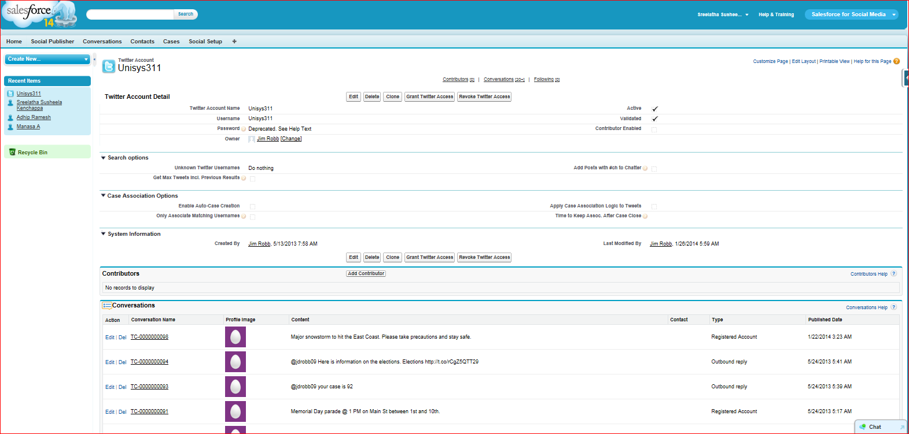

Sample Social Agent Page

Execute Twitter Search - Manually

Execute Twitter Search - Automatic

